Computer Networks – CS 3001

Instructor: Sir Farrukh Salim Sheikh– 5H

Group Members:

Anusha Saad 19K-0281  
Saman Khan 19K-0354

Date of Submission: 16-05-2022

PROJECT REPORT

Reconfigurable-Intelligent-Surface EmpoweredWireless Communications: Challenges and Opportunities

# **Abstract**

The propagation medium has been viewed as a randomly behaving entity between the transmitter and the receiver since the dawn of the modern era of wireless communications, downgrading the quality of the received signal due to the uncontrollable interactions of the transmitted radio waves with the surrounding objects. Existing wireless systems are built on the premise that radio environments are stable and uncontrollable exogenously. On the other hand, the recent introduction of Reconfigurable Intelligent Surfaces (RISs) in wireless communications allows network operators to regulate the scattering, reflection, and refraction properties of radio waves while avoiding the detrimental impacts of natural wireless propagation. The RIS protocol is a viable way to create a customizable wireless environment. It may be used to manipulate the electric and magnetic characteristics of a surface to regulate the propagation of electromagnetic waves, the characteristics of radio channels can be changed by putting these surfaces in an environment. The study examines channel state information gathering, passive information transmission, and low-complexity resilient system design as three major physical-layer issues for integrating RISs into wireless networks. It explores prospective research areas as well as other intriguing RIS research directions, such as edge intelligence and physical-layer security.

# **Introduction**

# Wireless demand is expected to continue to rise rapidly over the next five years, therefore planning for the future of wireless begins now. It requires a lot of bandwidth to combine phone, data, and the internet. To meet the apparently insatiable demand for mobile data, major wireless carriers are continually improving their networks by adding frequencies and technology. Traditional reflect-arrays, liquid crystal surfaces, and software-defined meta-surfaces are among the current implementations. In contrast to any other technology currently in use in wireless networks or current wireless communications design principles, the distinguishing feature of RISs is that they allow telecommunication operators to control the environment by allowing them to shape and fully control the EM response of environmental objects distributed throughout the network. Data sensing, collecting, transmission, and processing across future wireless networks will require ultra-high data rates, ultra-high dependability, ultra-low latency, and extraordinarily huge connection. This is accomplished through the use of key enabling wireless technologies such as massive multiple-input multiple-output (MIMO), millimeter wave (mmWave), ultra-dense networks, and AI-powered wireless networks, as well as new network functionalities like edge computing, caching, learning, and network slicing [1]. RISs are often made up of planar (or even conformal) artificial meta-surfaces with a large number of reflection amplitude/phase changes that are controlled by a programmable controller. This study aims to provide research results on advances in IRS-aided wireless communication networks, while also serving as a stimulus to promote and accelerate the development of wireless communication in the future, as RISs have a huge potential to revolutionize the design of wireless networks, especially when combined and integrated with other promising wireless technologies like ultra-massive MIMO, terahertz communications, and AI-powered wireless networks.

# **Reconfigurable Intelligent Surfaces and Their Challenges:**

The RISs are reconfigurable sheets of EM material that alter the propagation of signals in the environment to improve signal quality at the receiver. The RISs are made up of a vast number of low-cost and passive components that may alter the radio waves that travel through them in ways that naturally occurring materials cannot. The RIS is built up of meta-surfaces that operate as programmable reflectors in the basic example below. The RISs, unlike other related technologies like as relays and MIMO beam-forming, do not require a power supply or complicated processing, encoding, and decoding algorithms [2].

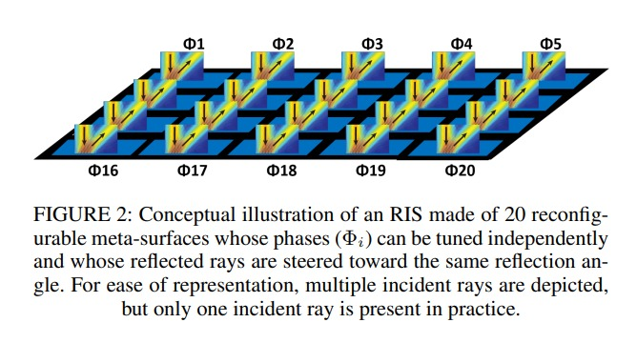

The performance benefits of RIS-enabled smart radio are clear. Some advantages are mentioned below:

* It may be used practically everywhere to capture electromagnetic waves that would otherwise be lost in space.
* To satisfy the necessity of green communications, RISs are ecologically beneficial. RIS-assisted methods incorporate little more energy than typical wireless systems since the RISs are practically passive.
* Since RISs only reflect electromagnetic waves, they can allow full-duplex and full-band transmission.
* RISs are also cost-effective since they do not require analog-to-digital or digital-to-analog converters or power amplifiers. In contrast to the linear power scaling law of a traditional active antenna array, the power gain of a RIS follows a quadratic scaling curve.

Unfortunately, the utilization of RISs introduces a variety of special issues for wireless communication network transmitter architecture. The core focus of this study was on three physical-layer problems: channel state information (CSI) estimate, passive information transmission, and low-complexity resilient system design. Those were all chosen because they constitute inherent and unique design flaws for RIS-assisted wireless networks.

# **Channel State Information Acquisition in RIS:**

Channel state information (CSI) in wireless communication refers to a communication link's known channel attributes. This data depicts the combined impact of scattering, fading, and power decay with distance as a signal travels from the transmitter to the receiver.

**Problem**

The procurement of CSI is a critical issue for RIS-assisted wireless networks to overcome obstacles. In RIS-assisted systems, CSI acquisition leads to a cascaded channel estimate issue, which is the difficulty of estimating the user-RIS and RIS-BS channel linkages based on their noisy product. In contrast to the linear estimation problem used in traditional communication systems, the cascaded channel estimation issue is typically a quadratic estimation task. Furthermore, because of the vast size of RIS, a large number of channel coefficients must be calculated, rendering the cascaded channel estimation problem more challenging.

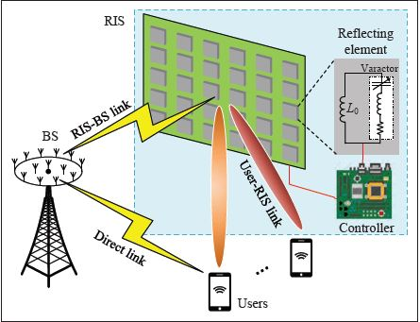

**Solution**

1. **Active-Channel-Sensor Based CSI Acquisition:**

The active channel sensors are inserted into the array of passive devices to sense channel information. Each active channel sensor contains an RF phase shifter that acts as a passive reflecting element for the incident electromagnetic (EM) wave, as well as a separate baseband processing unit for channel estimation [1].

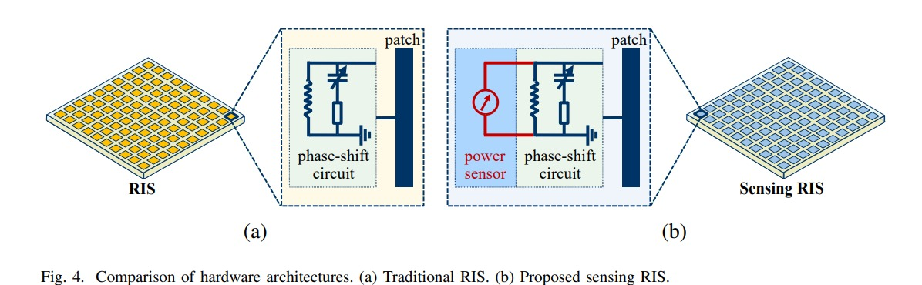

1. **Channel-Decomposition Based CSI Acquisition:**

To overcome this issue, breakdown the cascaded channel into a number of easier-to-estimate sub-channels and activate each user one at a time, i.e., the cascaded channel is decomposed into a series of single-input multiple-output channels visible by each user. In [5], the authors suggested a three-phase channel estimation approach that reduces the needed pilot length to the formula below.

$$K+N+max\left(K-1, \frac{\left(K-1\right)*N}{M}\right)$$

Where M and N are the numbers of the antennas/elements at the BS and at the RIS, respectively with K being the number of user.

1. **Structure-Learning Based CSI Acquisition:**

A sparse matrix factorization stage estimates the value of the RIS-BS channel connection, whereas a matrix completion stage estimates the information of the user-RIS channel link. The table below shows a heuristic comparison of the minimal training durations of the channel estimation techniques in [3-6] vs. the number of RIS components.

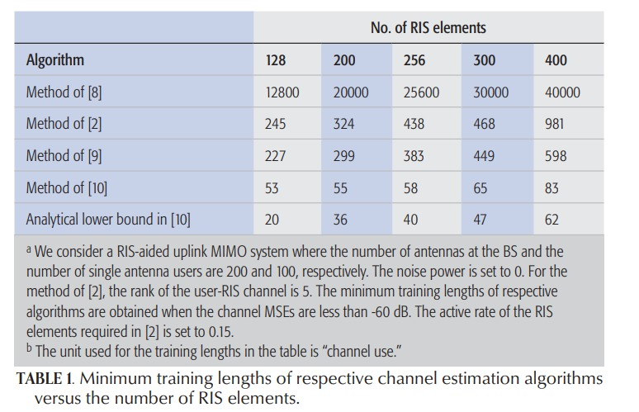

**Research Challenges**

1. Channel modelling and channel acquisition
2. System design under CSI uncertainty

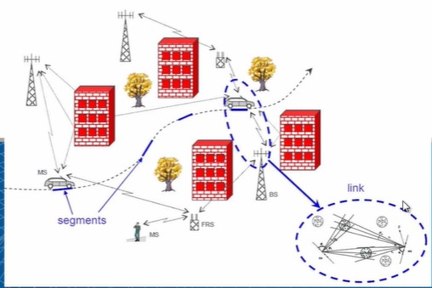

# **Passive Information Transfer of RIS:**

The majority of previous research has targeted about using RISs to improve primary end-to-end transmissions by implementing passive beam-forming. Following are some RSI information resources:

1. Control signal of RIS
2. Maintenance of RIS
3. Assistance of CSI acquisition

**Problem**

A neighboring radio frequency (RF) signal generator supports RIS which sends an unamplified carrier frequency to the RIS, and the RIS modulates its info onto the projected carrier frequency to send RIS data. However, the usage of a specialized RF signal generator, on the other hand, is not cost-effective.

**Solution**

1. For RIS-aided communication systems, the authors presented a combined passive beam-forming and information transfer (PBIT) approach that attempts to concurrently convey RIS information while improving primary medium quality.
2. To transfer RIS information in a totally passive way, the authors proposed using spatial modulation on the index of the RIS elements. That is, RIS data is conveyed by controlling the on/off states of the RIS components. It is more promising than the PBIT technique since it does not consume any additional time/frequency resource in information transfer.

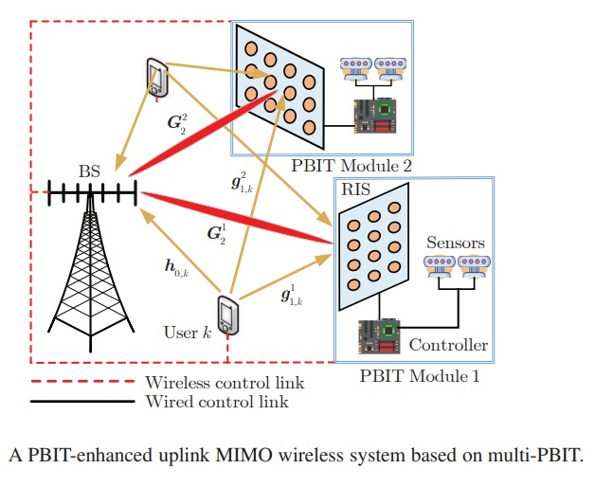

**Research Challenges**

1. Reconfigurable Intelligent Surface (RIS) design
2. Joint transceiver and RIS design

# **Low-Complexity Robust System Design:**

The trade-off in performance of the system and computational cost is discussed in this section. The huge number of RIS components, system performance is frequently resistant to individual element phase adjustment errors.

* **Robustness Against Channel Estimation Errors**

|  |  |
| --- | --- |
|  |  |
| When the normalised mean square error (MSE) is as great as –10 dB, the loss in data rate is negligible, as seen in this graph. Intuitively, this is because the necessity for precise phase calibration is negated by the huge number of RIS elements. | The graph shows the evolution of the message passing technique for Bayesian matrix factorization. Within the first 100 iterations, the algorithm achieves –15dB normalized MSE [6]. |

1. **Other Challenges of RIS-Aided Wireless Communication:**

Wireless security is critical, and there has been a surge in interest in developing safe data transmission based on the physical features of the wireless channel.  The usage of RISs creates a whole new approach for preventing data leaks and ensuring security measures by manipulating the propagation conditions surrounding unsafe nodes. This is accomplished by intelligently altering or reprocessing current signals using wireless link propagation programming to increase signals for genuine users while canceling out signals for unauthorized parties.

# **Conclusion**

The fundamental physical-layer concerns linked to the implementation of RISs in realistic wireless networks, namely CSI collection, passive information transfer, and low-complexity robust system design, were explored in this report. The primary difficulties and solutions for each of these problems are presented. Other issues with RIS architecture were briefly discussed. Finally, this paper is an earnest effort to give meaningful insight for future studies on RIS-assisted wireless networks.

# **Bibliography**

[1] Yuan, Xiaojun, et al. "Reconfigurable-intelligent-surface empowered wireless communications: Challenges and opportunities." *IEEE Wireless Communications* 28.2, Feb. 2021, pp.136-143.

[3] Z.-Q. He and X. Yuan, “Cascaded Channel Estimation for Large Intelligent Metasurface Assisted Massive MIMO,” *IEEE Wireless Communications*, vol. 9, no. 2, Feb. 2019, pp.210–14.

[4] D. Mishra and H. Johansson, “Channel Estimation and Low-Complexity Beamforming Design for Passive Intelligent Surface Assisted MISO Wireless Energy Transfer,” *Proc. IEEE* *Int’l. Conf. Acoust. Speech Signal Process, (ICASSP)*, Brighton, UK, 2019, pp. 4659–63.

[5] Z. Wang, L. Liu, and S. Cui, “Channel Estimation for Intelligent Reflecting Surface Assisted Multiuser Communications: Framework, Algorithms, and Analysis,” *IEEE Trans. Wireless* Communications, vol. 19, no. 10, Oct. 2020, pp. 6607–20.

[6] H. Liu, X. Yuan, and Y.-J. A. Zhang, “Matrix-Calibration-Based Cascaded Channel Estimation for Reconfigurable Intelligent Surface Assisted Multiuser MIMO,” *IEEE JSAC*, vol. 38, no. 11, Nov. 2020, pp. 2621–36.